Coloring is an activity that we tend to associate with children. As we grow older, we put aside our crayons and colored pencils in favor of more respectable writing utensils like pens and highlighters. However, it turns out coloring can be beneficial for adults -- namely for its de-stressing power.
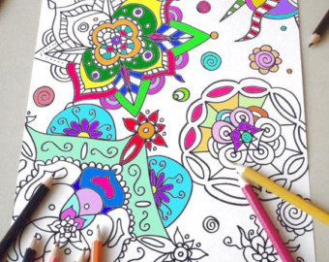
The practice generates wellness, quietness and also stimulates brain areas related to motor skills, the senses and creativity.

Take an hour out to de-stress with coloring therapy.
Crestwood Library 4955 w. 135th Street
708-371-4090 (or call Terry for more info 708-404-8900)
Wednesdays 2:30pm – 3:30pm
Thursdays 6:30pm – 7:30pm

